CECS 543 Lab 5 Add SMI to your project.

Due Feb 27, End of lab

An easy bit (we hope). We're going to add a panel for tracking the Software Maturity Index. It's pretty straight forward. Use a table to hold the data from the SMI. You recall that that is Total Modules, Added Modules, Deleted Modules and Changed Modules in a simple ratio: SMI = (Total - (Added+Changed+Deleted))/Total.

The SMI panel (there can be only one per project) as newly created looks like this:
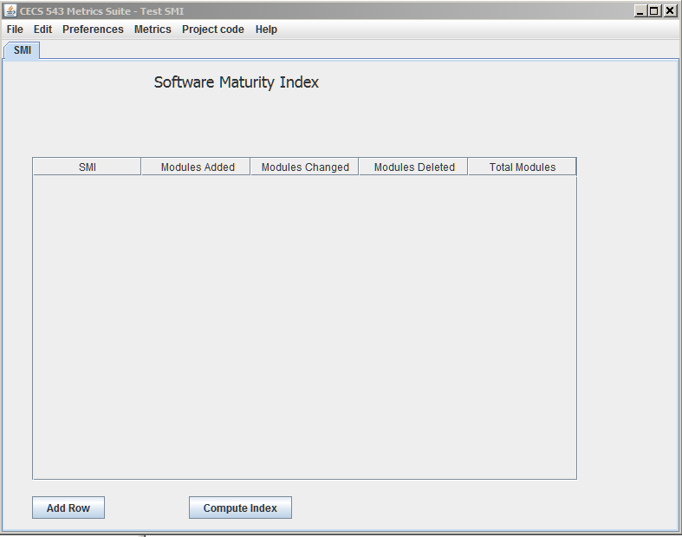

Clearly this metrics would begin to be tracked at the project's (our company's project, CECS 543 Metrics Suite) release. The first row to be added should be only "Added Modules". So, dead simple, add a row to the table by pressing the Add Row button to get this
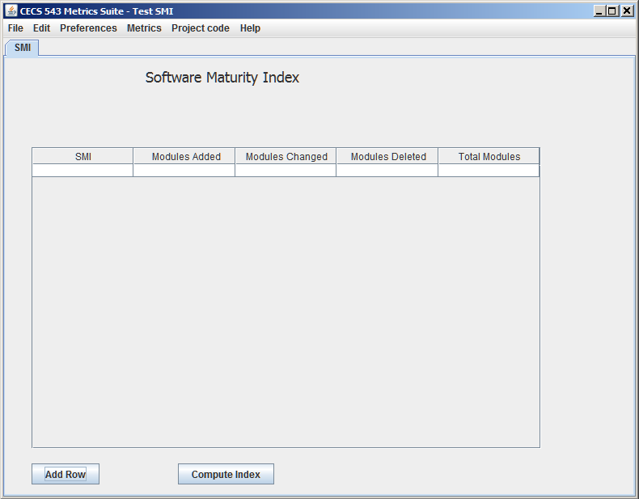

Enter some value in Modules Added, zero in Modules Changed and Modules Deleted. Press Compute index. You get this:
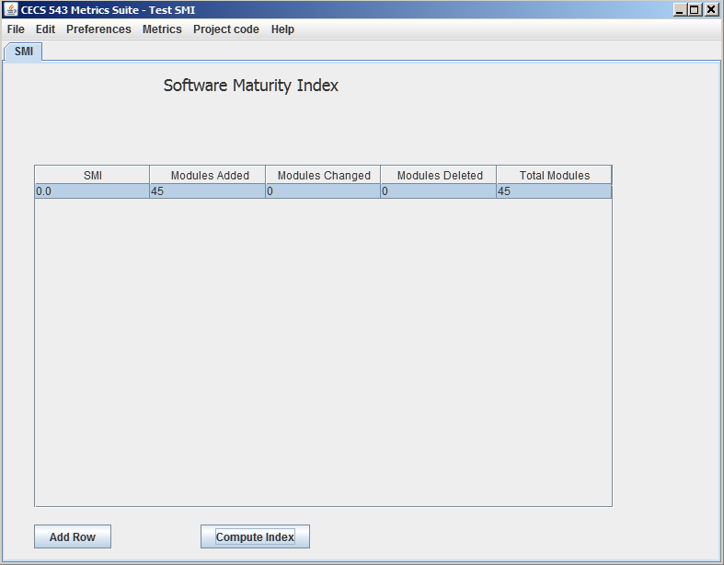

The "Total Modules" text box must be computed by your program. On all subsequent rows, the previous row's total must be accessed. Adding a second row looks like this:
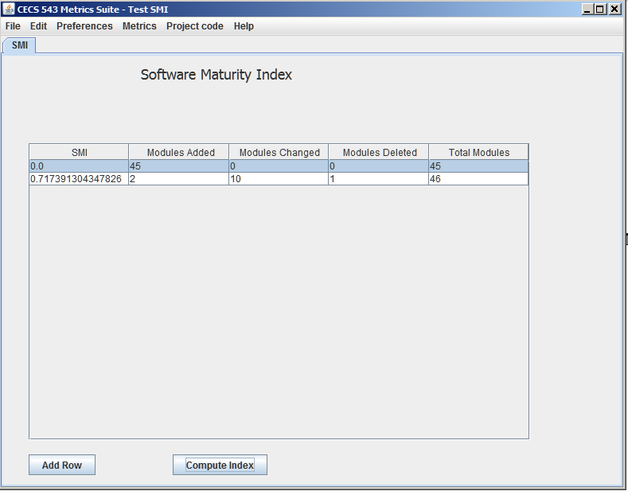

Clearly, 2 modules added, 10 changed, 1 deleted, total is 45+2-1=46.

The SMI must be saved along with all other "project" data and restored upon opening the project if the window was open the project was saved, or just read if the window was closed. (We haven't defined it yet, but we're going to need a mechanism for determining what windows were open and closed upon saving, and we need a means of closing and then reopening a closed window while the project is active.)

Add this feature - don't allow a user to construct any metrics panel without first making a project. So simply "gray out" any panel creation until a project has been created.

Also, don't allow the user to quit if they haven't saved. Do a "Save / Discard Changes" dialog and make the program act accordingly.

